Research Question: What Degree do Marriage and Gender Effect Life Satisfaction?
Table 1A.
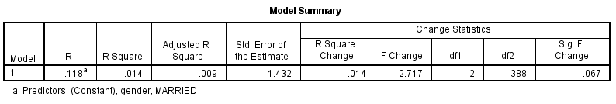
Table 1B.
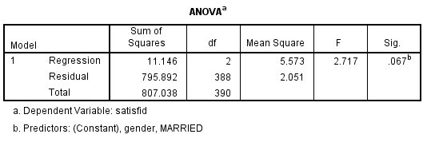
Table 1C.
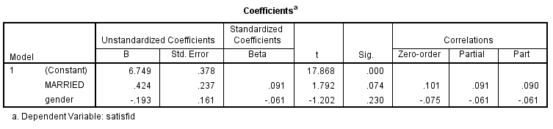
*The regression Equation identified was insignificant.
F (2,388) = 2.717, p<.067 with R² of .118.
Methods: A multiple regressions analysis was conducted to investigate the degree to which gender and being married predicts being satisfied. Gender is defined by male (115) or female (276). Whereas married is defined as single divorced never married or widowed (42) or married (349). People were assessed through a survey administration, (LSQ) Life Sphere Questionnaire.
Results: Participants’ predicted satisfaction level Is equal to 6.749 -.193 (gender) +.424 (married), where gender is coded as male=1 and female=2, and married was determined as single, divorced, never married, or widowed (0) and married (1).Males scored .193 higher on their satisfaction scores than females. The results are based on a sample size (n=391).
Conclusion: These results indicated participants’ life satisfaction was higher in males .143 and neither gender nor married was identified as significant p <.074 and p<.230, respectively. Convenience sampling could have affected the results, gender is predominantly female (276) and 89.96% of people identified as married. This is an inaccurate representation of the general population. Future research should focus more on gender dynamics and marital relationships. Pre- post surveys of satisfaction engagement to newlywed follow up. Specification of life satisfaction versus a generalized survey instrument designed to test multiple factors could potentially yield significant results.

